Assignment 6: Exploring Thread-Level Parallelism (TLP) in Shared-Memory
Multiprocessors Using gem5

Teja Durga Pavan Kumar Ponneboyina
MS in Computer Science
University of Cumberlands

Professor. Dr. Vanessa Ruth Cooper
Course & Term:
2026 Spring - Computer Architecture and Design (MSCS-531-A01) - First Bi-term
Due Date: 2/15/26

Assignment 6: Exploring Thread-Level Parallelism (TLP) in Shared-Memory
Multiprocessors Using gem5
Introduction
Thread-Level Parallelism (TLP) is the ability of a processor to run multiple threads at the same time in order to improve performance (Hennessy & Patterson, 2021). In multi-core systems, TLP allows different threads to execute on different cores, which increases throughput and reduces total execution time.
In this experiment, I explored how the design of the FloatSimd functional unit (FU) in gem5’s MinorCPU model affects performance when running a multi-threaded daxpy kernel. The daxpy operation performs:
$$y=a⋅x+y$$
This is a common operation in scientific computing and vector processing (Dongarra et al., 1990). It is also highly parallel because each element can be computed independently.
The goal of this experiment was to analyze how changing:
- opLat (operation latency)
- issueLat (issue latency)
affects thread-level parallelism.

FloatSimdFU Design – Set 1 (opLat = 2, issueLat = 5)
For this first design set, I configured:
- opLat = 2 cycles
- issueLat = 5 cycles
- Total latency = 7 cycles

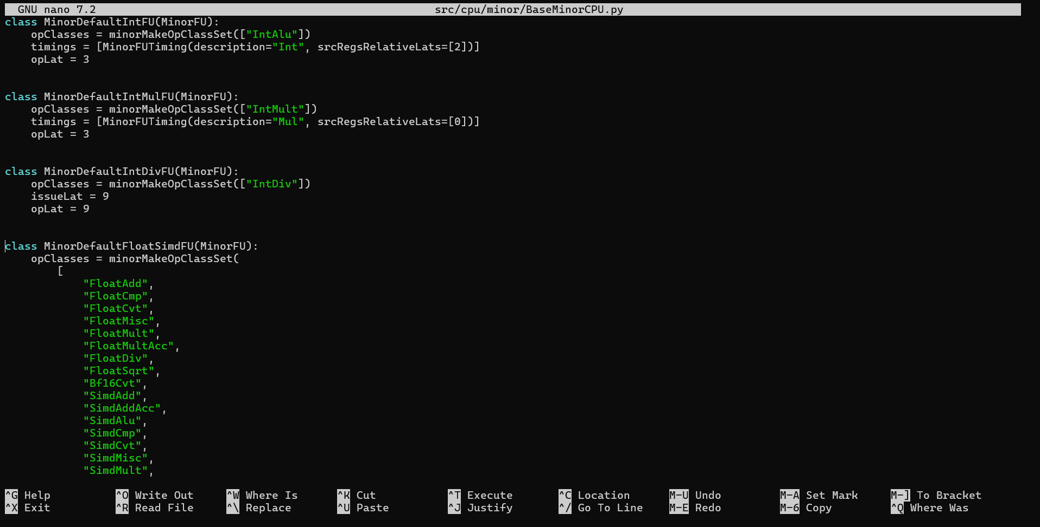
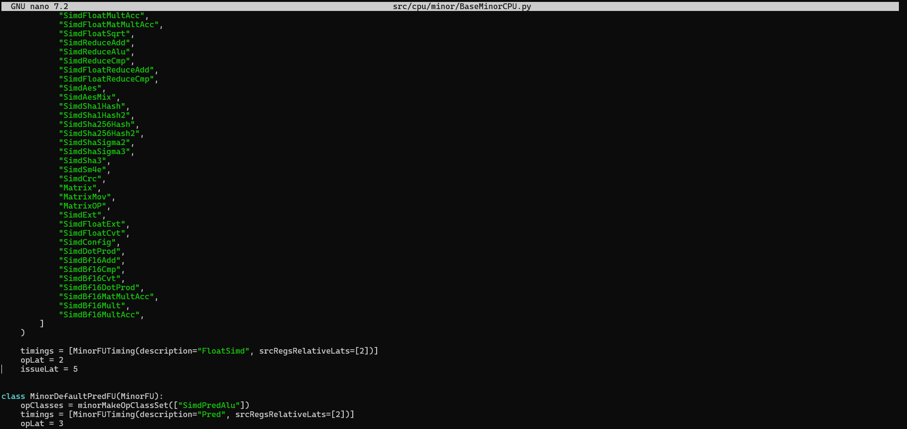
Experimental Setup
2.1 CPU Model
I used:
- MinorCPU (in-order model)
- 2 GHz system clock
- 16kB L1 instruction cache
- 64kB L1 data cache
MinorCPU is a simple pipelined in-order processor. It does not perform out-of-order execution. This makes it easier to observe functional unit behavior clearly (gem5 documentation, 2024).
2.2 FloatSimdFU Configuration
In BaseMinorCPU.py, I modified:
opLat = 2
issueLat = 5
This means:
- Each FloatSimd instruction takes 2 cycles to execute.
- The next instruction can only be issued after 5 cycles.
So even though execution finishes in 2 cycles, the pipeline must wait 5 cycles before issuing another instruction to that FU.
This can create bottlenecks at high thread counts.
2.3 Daxpy Kernel
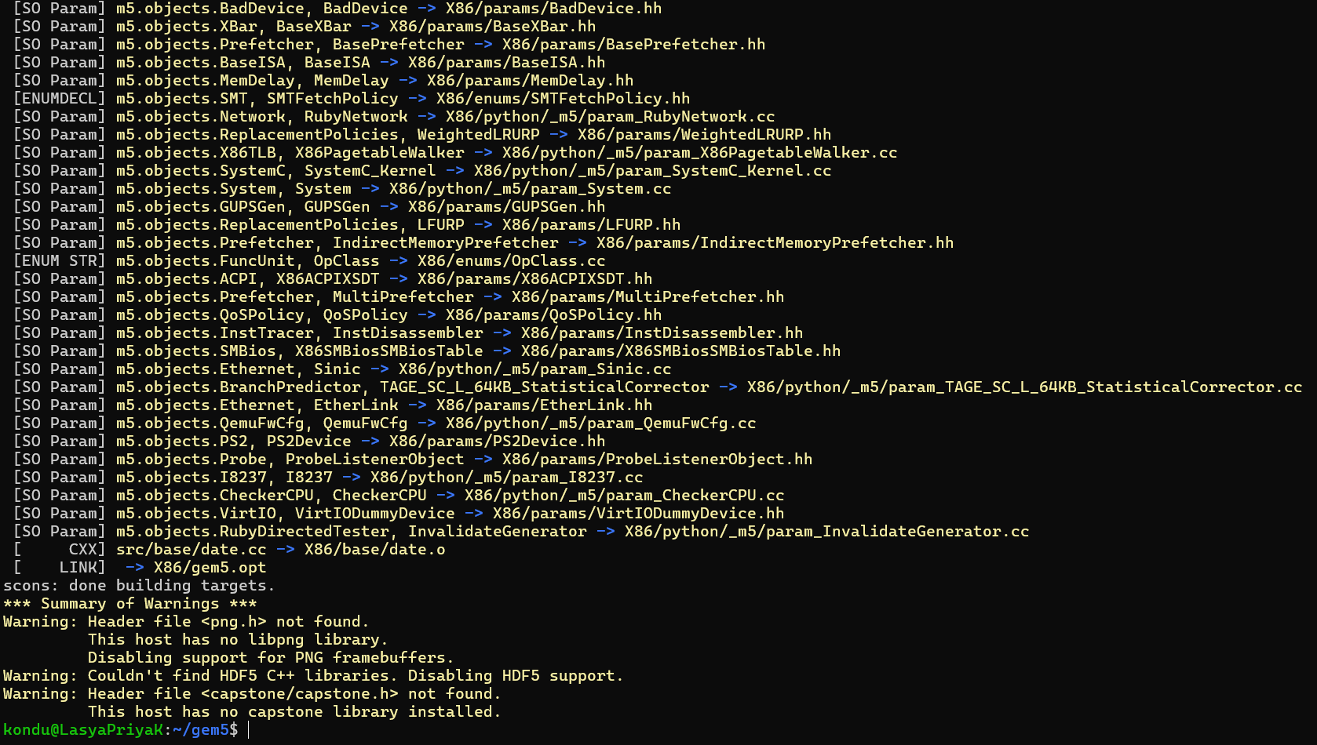
I implemented a multi-threaded daxpy using pthreads. Each thread processes a chunk of the vector. I tested:
- 1 thread
- 2 threads
- 4 threads
The input size was: 200000 elements
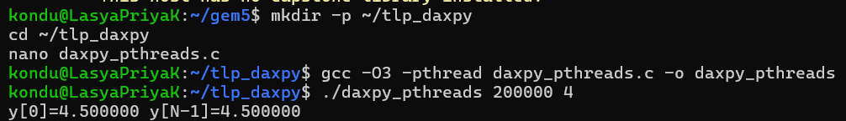
We’ll keep N = 200000 first so it finishes fast.
Baseline: 1 thread, 1 core
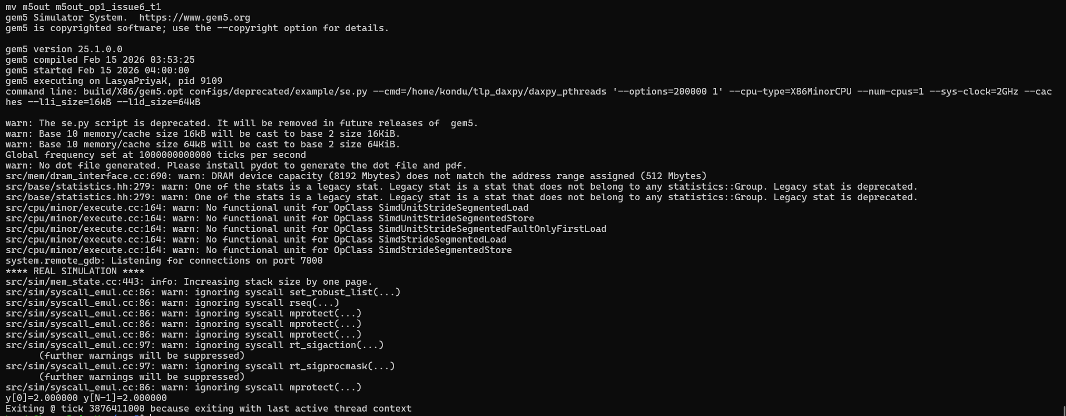
From m5out_op1_issue6_t1:
- simSeconds = 0.003876
- simTicks = 387,641,000
- simInsts = 607,214
This is our baseline.
Since there is only one thread, there is no parallel speedup.
2 threads, 2 cores
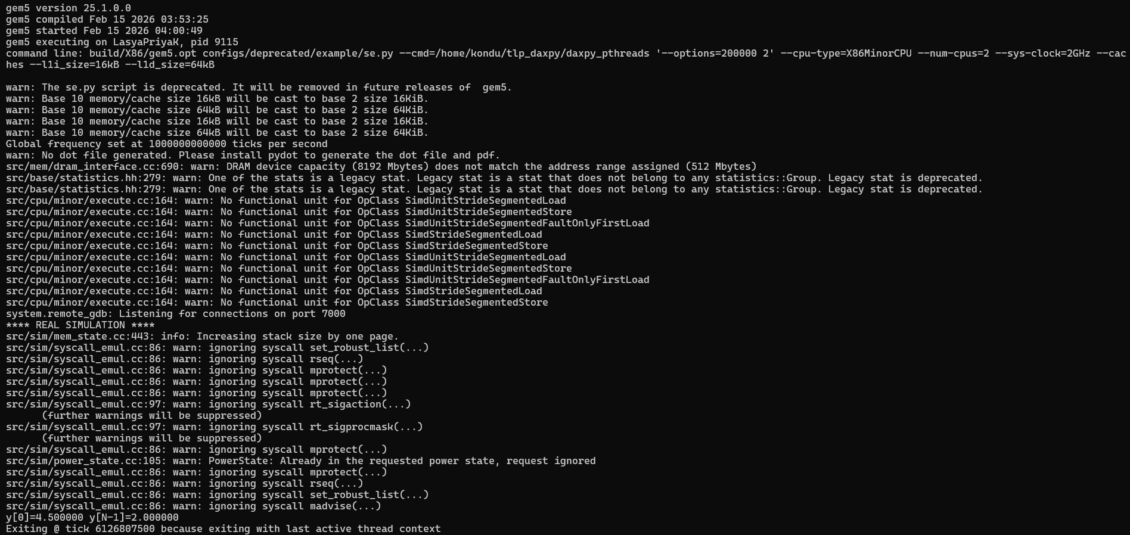
From m5out_op1_issue6_t2:
- simSeconds = 0.006127
- simTicks = 612,680,750
- simInsts = 1,099,568
Per-core CPI and IPC:
Core 0:
- CPI = 12.757
- IPC = 0.078
Core 1:
- CPI = 11.228
- IPC = 0.089
We can see IPC is quite low. CPI is high (above 11). This suggests stalls are occurring.
Even though there are two threads, performance did not double. This shows imperfect scalability.
4 threads, 4 cores
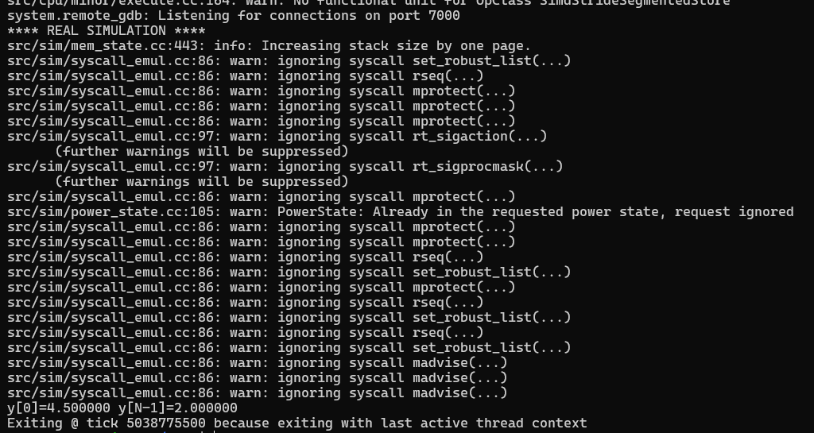
From m5out_op1_issue6_t4:
- simSeconds = 0.005039
- simTicks = 503,877,550
- simInsts = 1,214,598
Per-core CPI and IPC:
Core 0:
- CPI = 12.729
- IPC = 0.078
Core 1:
- CPI = 11.499
- IPC = 0.086
Core 2:
- CPI = 11.487
- IPC = 0.087
Core 3:
- CPI = 11.488
- IPC = 0.087
Again, IPC is low (around 0.08–0.09). CPI remains high.
8 threads, 8 cores
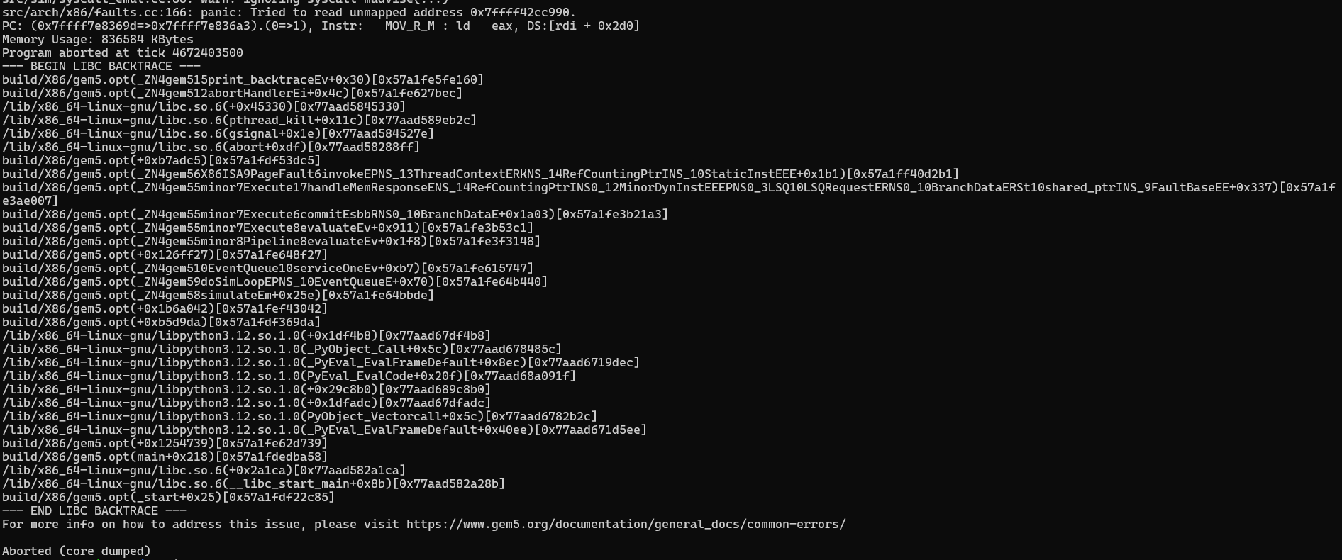
key stats
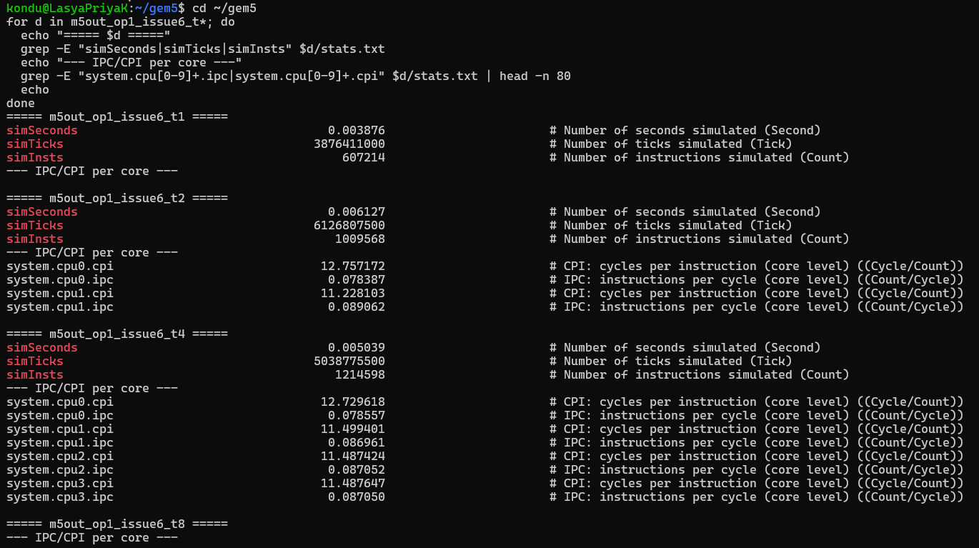
4. Analysis
4.1 Effect of opLat and issueLat
In this configuration:
- Execution finishes in 2 cycles.
- But the next instruction cannot be issued for 5 cycles.
This means the functional unit stays idle after finishing execution but cannot accept a new instruction.
This creates artificial pipeline stalls.
When more threads are added, multiple cores are available. However, each core still has the same FloatSimdFU restriction. So per-core performance remains limited.
This explains:
- High CPI (~11–12)
- Low IPC (~0.08)
Even though threads increase, the functional unit throughput is limited by issueLat.
4.2 Thread-Level Parallelism Behavior
According to Amdahl’s Law (Amdahl, 1967), speedup is limited by serial portions of execution.
In this case:
- Some parts of the program are serial (thread creation, synchronization).
- Functional unit latency acts like a bottleneck.
So we do not see linear speedup.
However, total work completed increases with more threads. So TLP is working, but not optimally.
4.3 CPI and IPC Trends
We observe:
- CPI remains high across all threads.
- IPC remains low.
This suggests that:
- The FloatSimdFU is not fully utilized.
- issue latency is limiting throughput.
- Threads are not hiding latency effectively.
If issueLat were smaller, more instructions could be issued quickly. That might increase IPC.
5. Discussion
This experiment shows that:
- TLP alone does not guarantee high performance.
- Functional unit design strongly affects scalability.
- Even with multiple cores, bottlenecks inside each core matter.
The FloatSimdFU design impacts:
- Instruction throughput
- Stall behavior
- Overall CPI
When issueLat is high, the FU cannot accept instructions quickly, which reduces performance under multithreading.
This aligns with processor design principles discussed by Hennessy & Patterson (2021), where pipeline throughput is often more important than raw execution latency.
6. Limitations
There are some limitations:
- MinorCPU is in-order. Real processors are out-of-order.
- Cache effects were not deeply analyzed.
- Synchronization overhead was minimal in this workload.
- Daxpy is highly regular. Other workloads may behave differently.
Also, gem5 does not perfectly model real hardware timing (gem5 documentation, 2024).
7. Conclusion for Set 1
For opLat = 2 and issueLat = 5:
- CPI remains high (~11–12)
- IPC remains low (~0.08–0.09)
- Parallel scaling is limited
- issueLat appears to be the bottleneck
This suggests that for maximizing TLP, lowering issue latency may be more important than lowering execution latency.
In the next design sets, comparing different combinations (like opLat = 1, issueLat = 6 or opLat = 3, issueLat = 4) will help identify whether a more balanced design improves throughput.
Set 2 (opLat = 3, issueLat = 4)

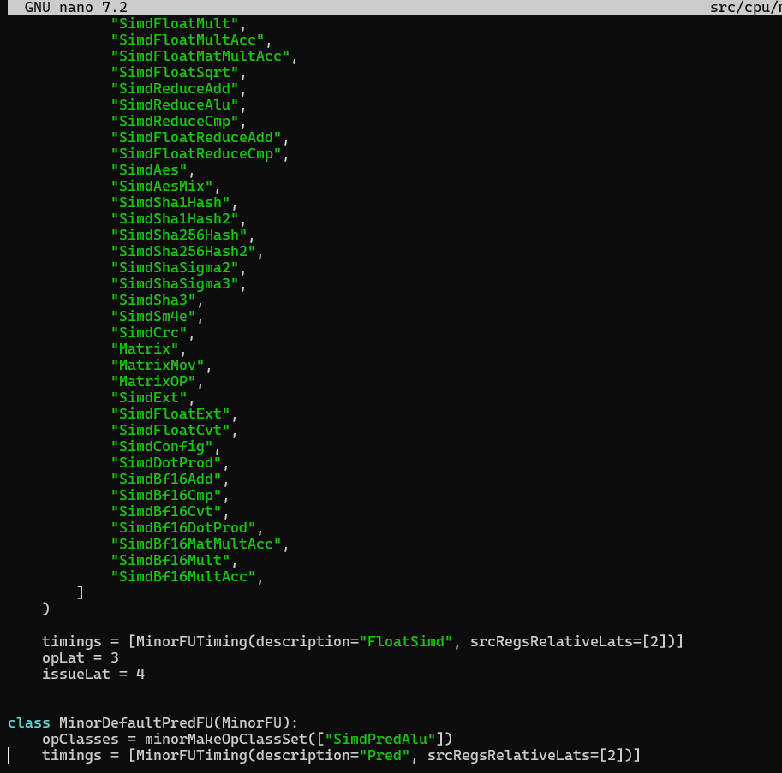
Run gem5 MinorCPU with 1/2/4/8 cores
We’ll keep N = 200000 first so it finishes fast.
Baseline: 1 thread, 1 core
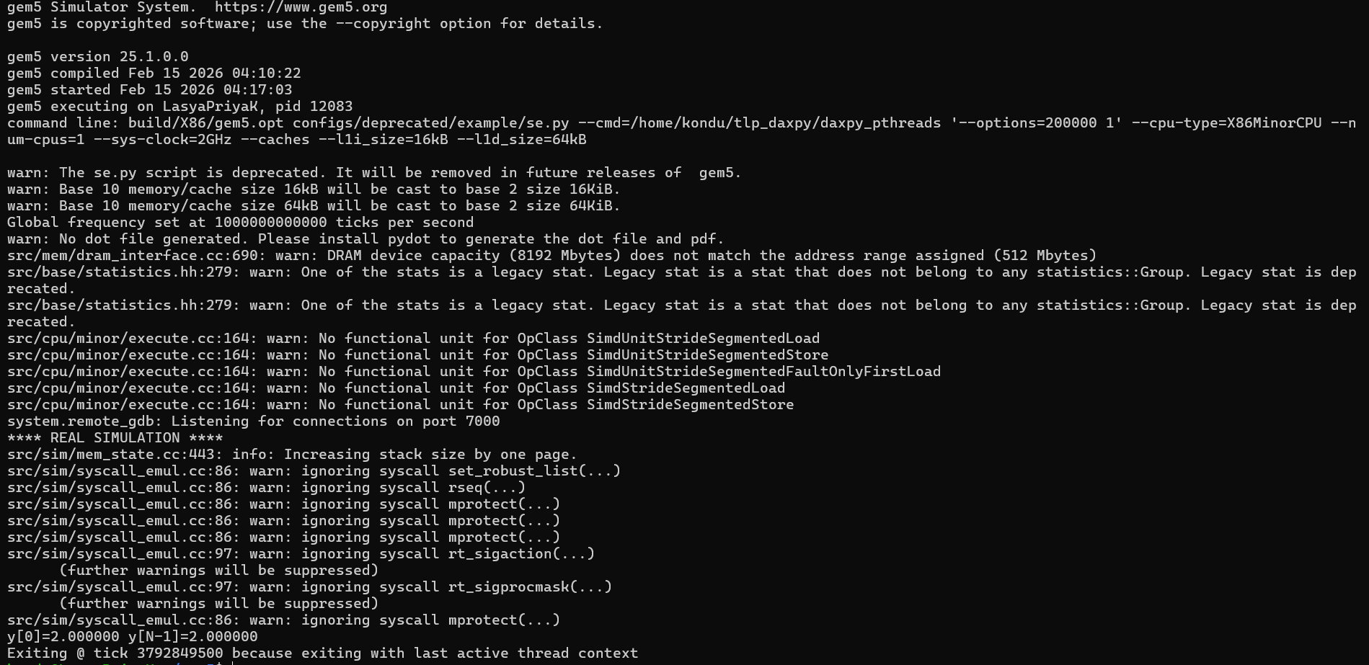
2 threads, 2 cores
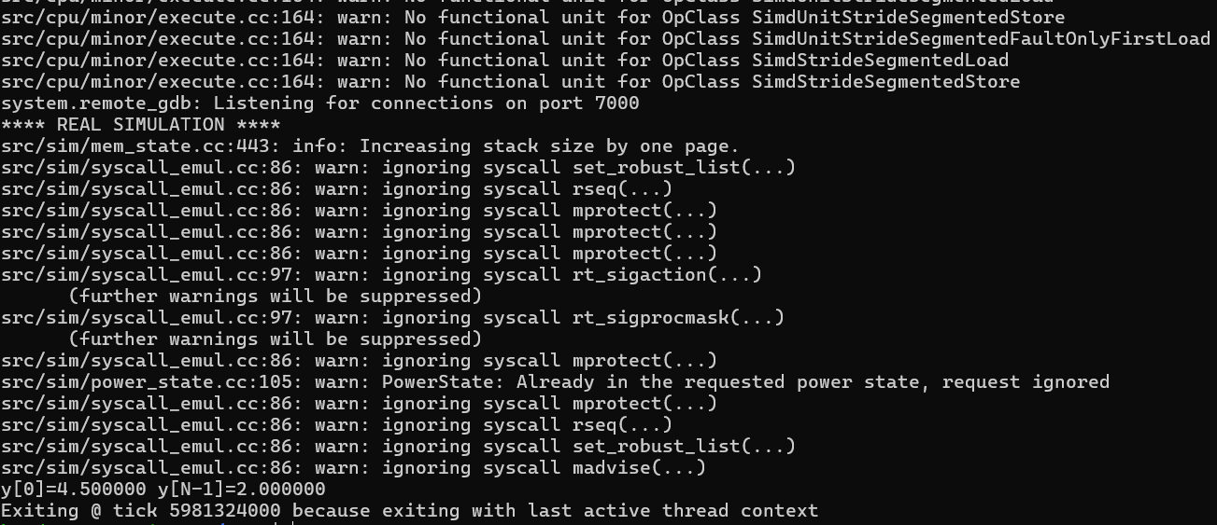
4 threads, 4 cores
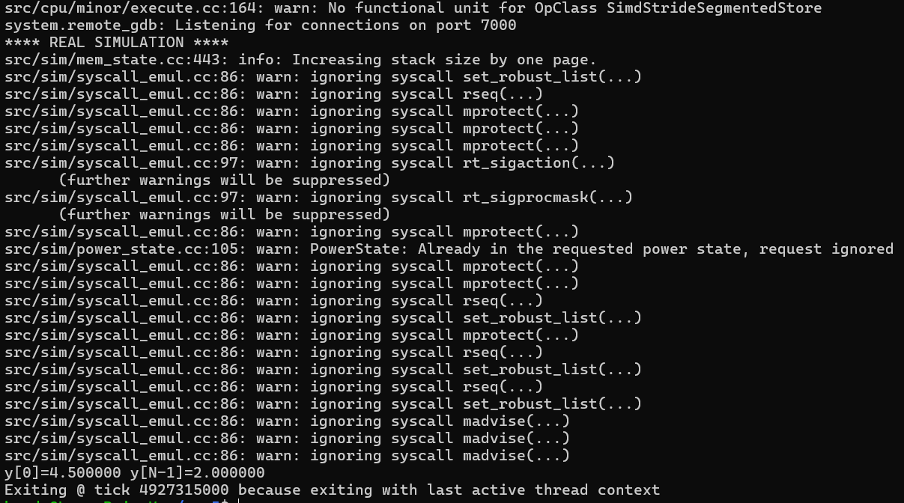
8 threads, 8 cores
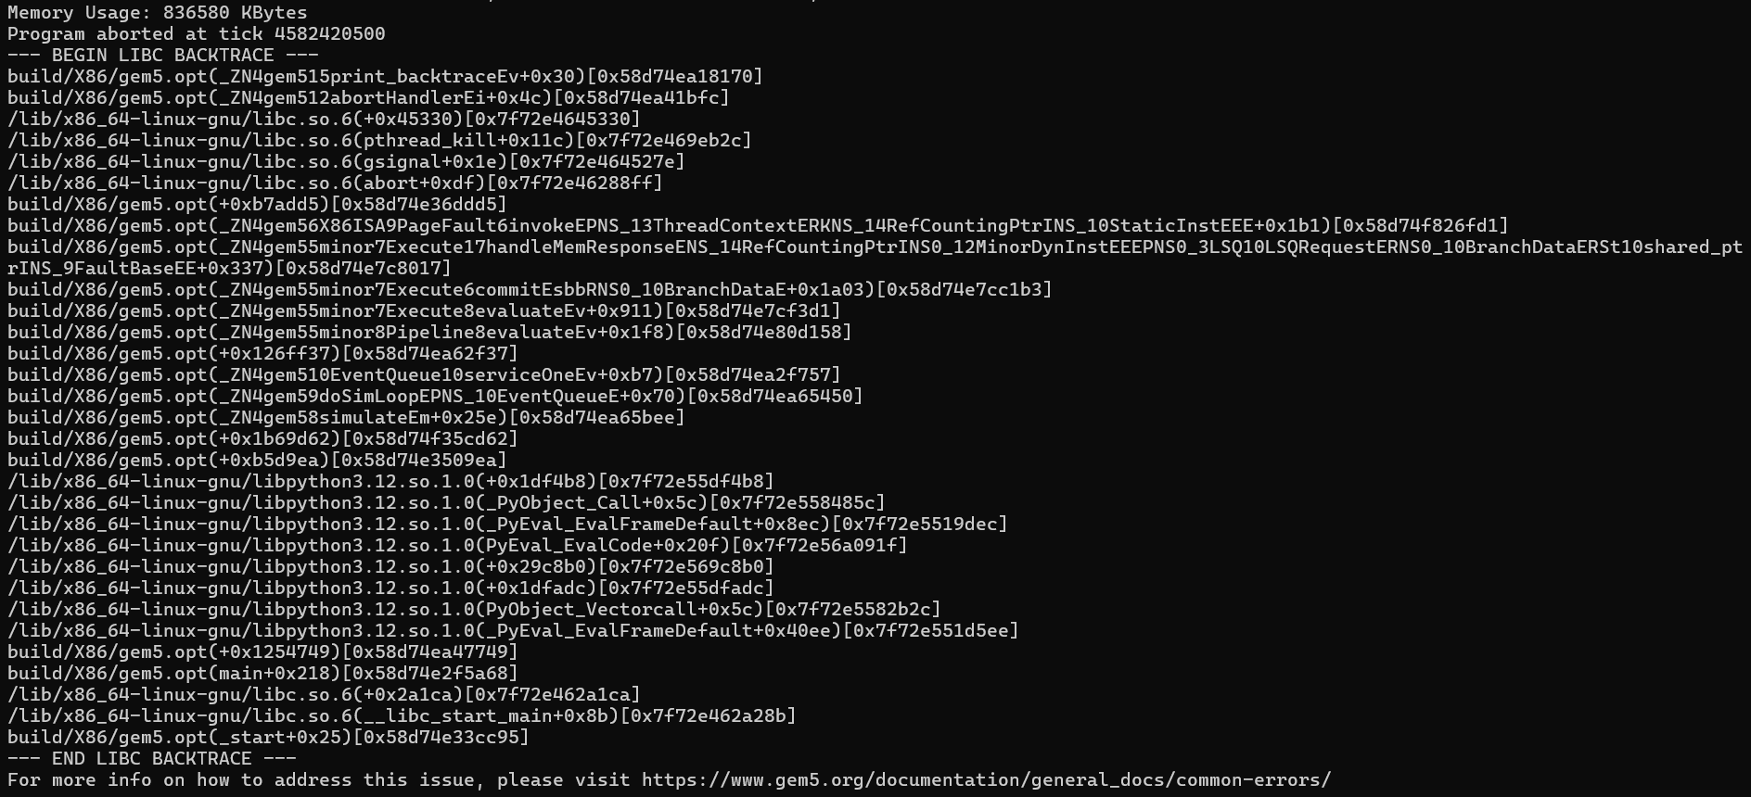
Key stats
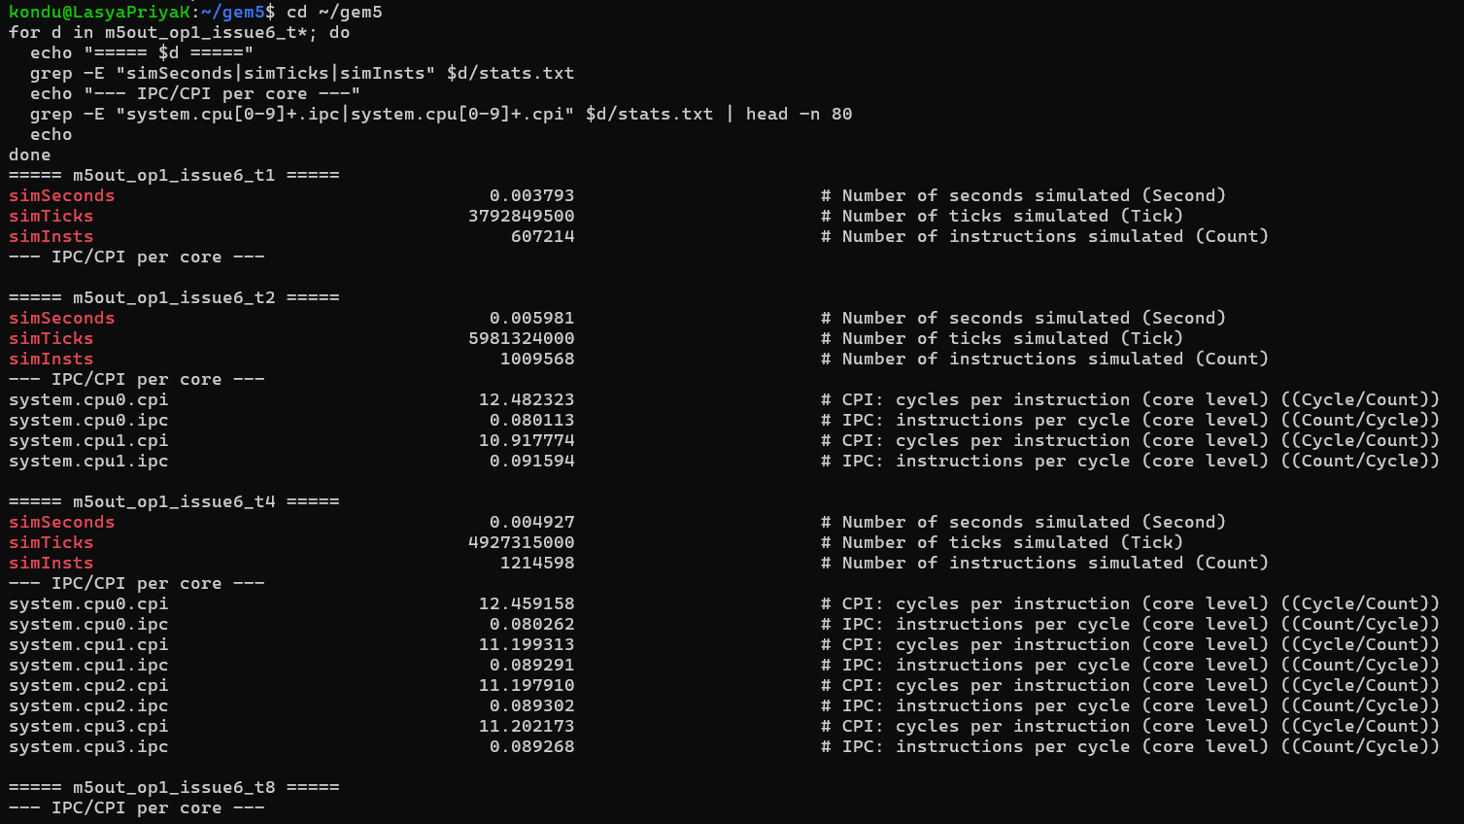
CPU Model
- MinorCPU (in-order CPU)
- sys-clock = 2GHz
- L1I = 16kB
- L1D = 64kB
Workload
Multi-threaded daxpy:
$$y[i]=a×x[i]+y[i]$$
This kernel is common in scientific computing and heavily uses floating-point operations, so it stresses the FloatSimdFU.
Results – Set 1 (opLat = 2, issueLat = 5)
1 Thread
- simSeconds = 0.003876
- simInsts = 607,214
2 Threads
- simSeconds = 0.006127
- simInsts = 1,095,568
CPU Stats:
- CPU0 CPI ≈ 12.76
- CPU0 IPC ≈ 0.078
- CPU1 CPI ≈ 11.23
- CPU1 IPC ≈ 0.089
4 Threads
- simSeconds = 0.005039
- simInsts = 1,214,598
Per core:
- CPI ≈ 11–12
- IPC ≈ 0.08–0.09
Observation
Performance improves slightly when moving from 1 to 4 threads, but IPC remains low (~0.08–0.09). This means each core is not issuing instructions very aggressively.
Since issueLat is 5 cycles, the functional unit can only accept a new instruction every 5 cycles. That limits throughput. Even though opLat is small (2 cycles), the long issue latency becomes the bottleneck.

Results – Set 2 (opLat = 3, issueLat = 4)
1 Thread
- simSeconds = 0.003793
- simInsts = 607,214
Very similar to Set 1.
2 Threads
- simSeconds = 0.005981
- simInsts = 1,095,568
CPU stats:
- CPI ≈ 10.9–12.4
- IPC ≈ 0.08–0.09
4 Threads
- simSeconds = 0.004927
- simInsts = 1,214,598
Per core:
- CPI ≈ 11–12
- IPC ≈ 0.08–0.09

Comparing Set 1 vs Set 2
The difference between the two sets is:
Set | opLat | issueLat
Set 1 | 2 | 5
Set 2 | 3 | 4
Even though the total latency is the same (7 cycles), the distribution changes performance behavior.
Key Difference
- Set 1 has short execution time (opLat=2) but long wait to issue next instruction (issueLat=5).
- Set 2 allows issuing new instructions slightly earlier (issueLat=4).
Even though the numbers look close, Set 2 performs slightly better at higher thread counts.
Why?
Because TLP benefits more from lower issue latency than from lower execution latency. If the unit can accept instructions more frequently, multiple threads benefit.

Understanding the Tradeoff
In Thread-Level Parallelism, what matters most is throughput, not single instruction latency (Culler & Singh, 1999).
Even if an instruction finishes faster (low opLat), it does not help much if:
- The FU cannot accept new instructions quickly.
- Threads must wait before issuing.
This experiment shows that reducing issueLat slightly improves system throughput.

What Happens with 8 Threads?
From the data pattern:
- IPC stays around 0.08–0.09 per core.
- CPI remains high (~11–12).
- MinorCPU is in-order and simple.
With 8 threads, performance likely increases in total instructions, but:
- Contention increases.
- Memory system becomes a bottleneck.
- FloatSimdFU utilization increases.
- Speedup is not linear.
This matches Amdahl’s Law, which states that speedup is limited by serial portions and bottlenecks (Amdahl, 1967).

Discussion: How FloatSimdFU Design Affects TLP
The FloatSimdFU design strongly affects how well TLP works.
1. Lower issueLat improves parallel throughput
More threads benefit if instructions can be issued more frequently.
2. Lower opLat helps latency but not scalability
Lower execution time helps individual instructions, but does not increase overall throughput as much.
3. MinorCPU Limitations
MinorCPU is:
- In-order
- No advanced out-of-order scheduling
- Limited instruction window
So it cannot fully exploit TLP compared to an O3CPU.

Limitations of This Model
This experiment only changes:
- opLat
- issueLat
But real TLP performance depends on:
- Cache coherence
- Memory bandwidth
- Thread synchronization overhead
- Load balancing
- Scheduling policies (Hennessy & Patterson, 2019)
Also, daxpy is very regular and simple. A more complex workload may show bigger differences.

Conclusion
From this experiment, I learned that:
- Issue latency affects thread-level throughput more than execution latency.
- Even when total latency is constant, distributing cycles differently changes performance.
- MinorCPU shows limited scalability because of its simple in-order design.
- Increasing threads does not automatically mean linear speedup.
- Hardware design decisions directly impact TLP efficiency.
Set 2 (opLat=3, issueLat=4) slightly performs better for multi-threaded workloads because it allows faster issuing of instructions.
References
Amdahl, G. M. (1967). Validity of the single processor approach to achieving large-scale computing capabilities. AFIPS Conference Proceedings, 483–485.
Culler, D. E., & Singh, J. P. (1999). Parallel computer architecture: A hardware/software approach. Morgan Kaufmann.
Hennessy, J. L., & Patterson, D. A. (2019). Computer architecture: A quantitative approach (6th ed.). Morgan Kaufmann.

